PETITES TARTES AUX FRUITS

FRENCH TARTES ARE DIFFERENT FROM AMERICAN PIES IN THAT THE DO NOT HAVE A TOP CRUST. THIS PERMITS THE BAKER TO DECORATE THE TARTES ARTFULLY. HAVE FUN!
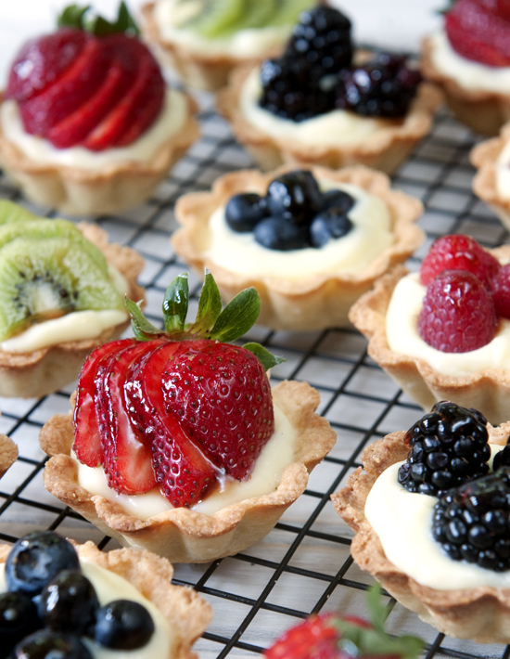
INGREDIENTS:

1 (3-ounce) package cream cheese, softened
1/4 cup sour cream
1 tablespoon orange juice
1/2 teaspoon vanilla
1 (2.1-ounce) package (15) frozen mini filo or pastry dough shells, thawed
Assorted fruit (strawberries, raspberries, blueberries, kiwis, mangos, mandarin oranges, drained crushed pineapple, etc)
1/4 cup current jelly, melted(in microwave for about 30 seconds)
Fresh mint leaves (for decoration)

Directions
- Combine cream cheese, sour cream, orange juice and vanilla in medium bowl until well mixed.
- Spoon about 1 teaspoon cream cheese filling into each filo shell.
- Top with fruit.
- Drizzle or brush melted jelly over fruit.
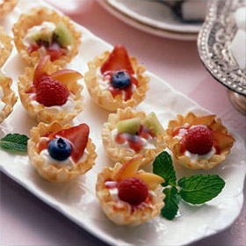
- Garnish with mint leaves, if desired.
- Cover and refrigerate up to 3 hours before serving.

THIS RECIPE CAN BE USED FOR MINI TARTS OR LARGE TARTS, DEPENDING ON THE SIZE OF THE SHELLS.

BON APPÉTIT!
